**Title: Development of a Device to Turn on on Contact Using a Photoresistor and Light Sensing**

**Introduction:** The objective of this project was to develop a device that turns on on contact. This device has potential application in a Head-Mounted Display (HMD) for Augmented Reality (AR) and Virtual Reality (VR) applications . The principle of working of this device is based on a photoresistor and light sensing technology. The device turns on by sensing the light in the surroundings when it comes in contact with a surface.

**Materials and Methods:** The device was developed using a photoresistor, an LED, a breadboard, and a power source. The photoresistor was used as the light sensor which detects the surrounding light intensity. The LED was used as an output device to indicate that the device is turned on. Both the photoresistor and LED were connected to the breadboard. The power source was connected to the breadboard to provide power to the circuit.

The working of the device is based on the fact that when the device comes in contact with a surface, the light intensity changes. This change in light intensity is detected by the photoresistor, which triggers the LED to turn on, indicating that the device is turned on.

**Results:** The developed device successfully turns on when it comes in contact with a surface. This was achieved using a simple circuit consisting of a photoresistor and an LED. The use of a light sensor reduces the complexity and cost of the circuit. However, it should be noted that this device may not work properly in totally dark environments as the photoresistor requires some amount of light to operate.

**Conclusion:** In conclusion, this project successfully developed a device that turns on on contact using a photoresistor and light sensing technology. This device has potential application in HMDs for AR and VR applications, where a device that turns on on contact may be beneficial. The use of a photoresistor reduces the cost and complexity of the circuit, but may require some light to function properly.

**Summary:**

**Objective**- To make a device which turns on on contact.

**Application** - the HMD for Ar/VR must turn on when work.

**Sensors used** - the Photoresistor is used in order to reduce the code.

**Principle of working**- when the sensor touches a surface, the light turns off, hence turning the device on. This does not work in totally dark areas, however this is the cost tradeoff as proximity sensors are more expensive than the cheap photosensors.

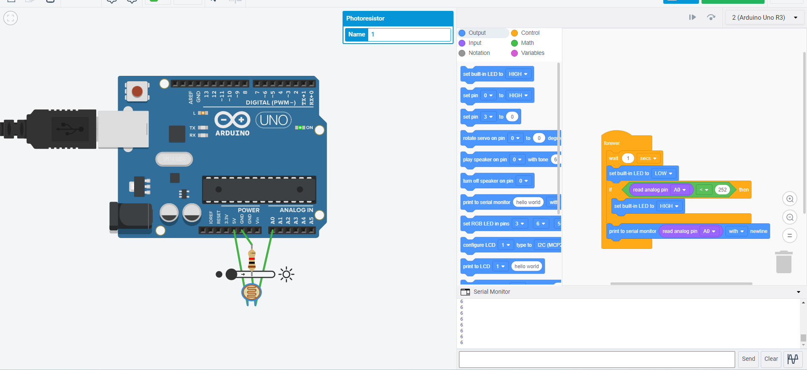

// C++ code

//

int seconds = 0;

void setup()

{

pinMode(LED_BUILTIN, OUTPUT);

pinMode(A0, INPUT);

Serial.begin(9600);

}

void loop()

{

delay(1000); // Wait for 1000 millisecond(s)

digitalWrite(LED_BUILTIN, LOW);

if (analogRead(A0) < 252) {

digitalWrite(LED_BUILTIN, HIGH);

}

Serial.println(analogRead(A0));

}

